Module List:

Claims Registration Screen 2

Claim Recovery 3

# Claims Registration Screen

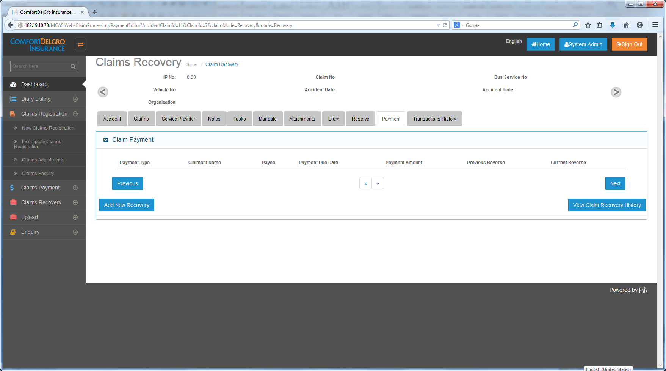

14-11-2014:

New Claims Registration

1. New Claims Registration – This Menu will be used for Claims Entries Creation for all Organization Category (e.g. Public Bus, Train, Taxi, Rental Vehicle, Private Bus, Private Bus).
2. Users under Public Bus and Train will use the Screen Layouts as per Claim registration presentation ( PPT file created by India Ebix Team ) for Claims Creation
3. Users under Private Car, Private Bus, Rental Vehicle and Commercial Vehicle will use the screen layouts as per Car Draft PDF file.
4. Users under Taxi will use another screen layouts (which is not provided as per this update)
5. If user is under one single Organization Type, clicking on the Claims Registration will bring user to its screen layout related to its Organization Type (e.g. User is under SBST which is under Public Bus so the screen will go to the Public Bus Screen Layouts)
6. If user is under multiple Organization Types, System will show a screen with a Dropdown and ask user which Organization to create the Claim. (e.g. if User is under SBST (Public Bus) and Comfort Delgro Buses (Private Bus) and when user selects Comfort Delgro Buses, the layout will change to those under Private Bus.

Incomplete Claims Registration

1. All File uploads (TAC and SAP) will go to this Incomplete Claims Registration Menu.
2. We do not have any information for SAP File uploads as yet.
3. Any Saved Entries from New Claims Registration will go to the Incomplete Claims Registration.

# Claim Recovery

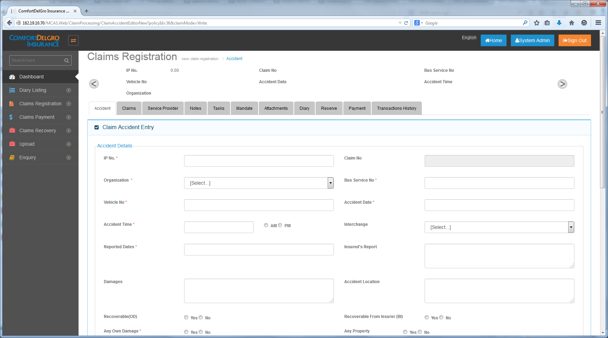

14-11-2014 (Transferred from Claims Recovery Doubts V1.docx) :

Claim Registration Screen

1. To Add A New Recovery Tab to the Claims Registration Screen.
2. Purpose: When user selects Recoverable (OD) = Yes and/or Recoverable from Insurer (BI) = Yes, all the Claim Entries will be populated to this Recovery Tab for overall view. User can click on the individual claim entries and it will bring user to the Claim Recovery UI at the Claim Recovery Menu to process the Recovery.
3. Suggested Grid Layout:

|  |  |  |  |  |  |  |
| --- | --- | --- | --- | --- | --- | --- |
| +/- | Claim Type | Claim No. | Claimant Name | Status | Action |  |
| + | OD |  |  | << Empty when none; Processed when Recovery is done>> | << Select >> |  |
|  |  |  |  |  |  |  |
| + | BI |  |  | << Empty when none; Processed when Recovery is done>> | << Select is only available for Status is empty >> |  |

Special Requirements :

Recovery for BI is to be done in a batch and for the first batch, the deductible (defaulted as $15,000) will be taken into account. Note that if the first batch is less than 15,000, user cannot go for BI Claims Recovery. If the first batch is processed, the deductible is no longer taken into account for the second batch.

How to define First Batch and Ongoing Batches – The first and ongoing Payment Entries (e.g. 1 – 5) made for BI Claims will be populated here. Once the user clicks on Select Link, the set of (1 – 5) BI Claims will be processed. The set of (6 – N) will be considered as Second Batch when the Select Link is clicked.

Claims Recovery Screen

When User clicks on Select Link under OD in the Recovery Tab or after searching:

Suggested Claim Recovery Screen For OD:

|  |  |
| --- | --- |
| **Field Name** | **Field Type** |
| Recover From | << Text Field >> |
| Address1 | << Text Field >> |
| Address2 | << Text Field >> |
| Address3 | << Text Field >> |
| Postal Code | << Text Field >> |
| Recovery Reason | << Text Field >> |

|  |  |  |
| --- | --- | --- |
|  | Recoverable Amount | Approved Mandate |
| << Listing to follow Payment Screen for OD >> | << Text Field >> | << Read Only – To Populate values from Mandate Entry that is approved for this particular OD >> |
|  |  |  |
|  |  |  |
|  |  |  |
| Total | << Total Amount from above inputs >> |  |
|  | << Submit Button >> |  |

Validation:

1. Recoverable Amount must be greater or equal to Approved Mandate Amount
2. When the Submit Button is clicked, the Total Amount will be deducted from Outstanding Reserve and Mandate Amount relevant to this OD Claim

Claims Recovery Screen

Search Fields Required:

* Claim No.
* Claimant Name
* Recoverable Type << Dropdown – Own Damage (OD) / Bodily Injury (TPBI) >>

When User clicks on Select Link under BI:

|  |  |  |
| --- | --- | --- |
| **Field Name** | **Field Type** | **Remarks** |
| Total TPBI Payout | << Text Field >> | This is pulled from the total values of TPBI Claims Payment |
| Deductible / Excess Limits (currently set as 15,000) | << Text Field >> | This value is pulled from CDGI’s Deductible value from own panel of Insurer or Insurance Policy (from System Admin) |
| Amount To Recover | << Text Field >> | Value = Total TPBI Payout - Deductible |
| Reason | << Text Field >> | Default to “Deductible Exceeded” |

Validation:

* For the first set of BI Recovery, Deductible (currently default as 15,000) is taken into account
* If Total TPBI Claims Payment is less than Deductible, Recovery cannot be processed. System to prompt user that this batch cannot be processed because Total TPBI Claims Payment is less than Deductible.
* If Total TPBI Payment is more than Deductible in the first batch, Recovery can be processed.
* This Entry is saved and the first batch is marked with a new status of processed and will not be allowed to use for ongoing batches.
* Deductible will not be taken into account for ongoing batches (which means any future recoveries can be processed).